S3 bucket task
- Create an S3 bucket and upload some objects to S3
Step 1: Create an S3 Bucket
- Sign in to the AWS Management Console.
- Navigate to Amazon S3.
- Click Create bucket.
- Enter a globally unique bucket name (example: varun-demo-bucket-2026).
- Select the AWS Region.
- Leave Block Public Access enabled (recommended).
- Keep other settings as default.
- Click Create bucket.
Step 2: Upload Objects to the Bucket
- Click the newly created bucket.
- Select Upload.
- Click Add files.
- Choose one or more files from your local system.
- Click Upload.
Step 3: Verify Object Access
- Click one of the uploaded objects.
- Review the object details such as:
  - Object name
  - Size
  - Last modified date
  - Storage class (Standard)

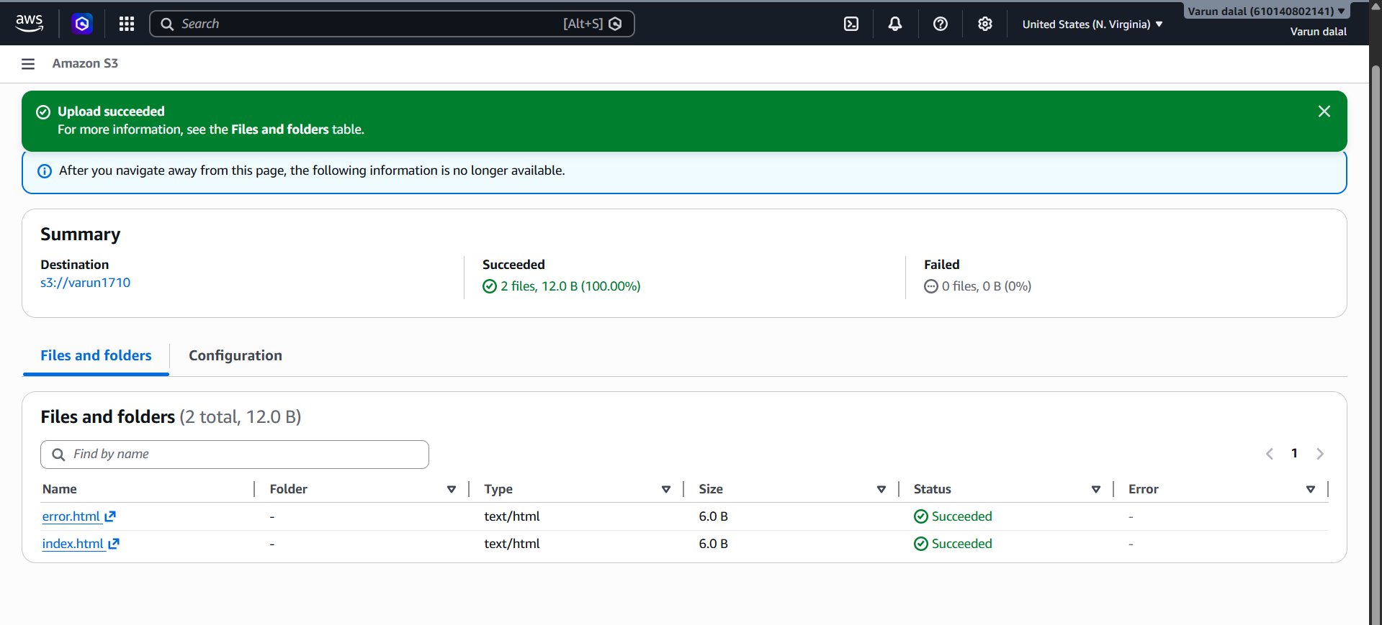
Task Outcome
The S3 bucket was successfully created, and two HTML objects (index.html and error.html) were uploaded successfully. Both files are stored in the bucket and are available for use. No upload errors were encountered, indicating that the bucket configuration and permissions are functioning correctly.
Validation Steps Performed
- Opened the S3 bucket varun1710.
- Verified that the bucket exists and is accessible.
- Uploaded index.html and error.html.
- Confirmed both files appear in the Files and folders section.
- Verified the upload status shows Succeeded for all objects.
- Confirmed there are 0 failed uploads.

2.Deploy a static website in the S3 bucket
Step 1: Open the S3 Bucket
- Go to Amazon S3 Console.
- Select your bucket varun1710.
Validation
- The bucket opens and displays the uploaded files:
  - index.html
  - error.html
Step 2: Enable Static Website Hosting
- Click the Properties tab.
- Scroll down to Static website hosting.
- Click Edit.
- Select Enable.
- Hosting type: Host a static website.
- Enter:
  - Index document: index.html
  - Error document: error.html
- Click Save changes.
Validation
- Static website hosting status changes to Enabled.
- An S3 Website Endpoint URL is generated.
Step 3: Make Objects Public
Since S3 static websites require public read access:
- Open the Permissions tab.
- Under Block Public Access, click Edit.
- Uncheck:
  - Block all public access
- Save changes and confirm.
Validation
- Public access is enabled for the bucket.
Step 4: Add Bucket Policy
- Go to Permissions → Bucket Policy.
- Paste the following policy
Validation
- Policy saves successfully without errors
Step 5: Test the Website
- Return to Properties.
- Copy the Bucket Website Endpoint URL.
- Open it in a browser.
Validation
Expected result:
- index.html page loads successfully.
- If a non-existent page is requested, error.html is displayed
Verification for Lab Submission
Take screenshots of:
- Static Website Hosting = Enabled
- Bucket Policy
- Permissions showing public access allowed
- Website Endpoint URL
- Browser displaying index.html
Expected Outcome: The S3 bucket varun1710 is configured as a static website, serving index.html as the home page and error.html as the error page. ✅

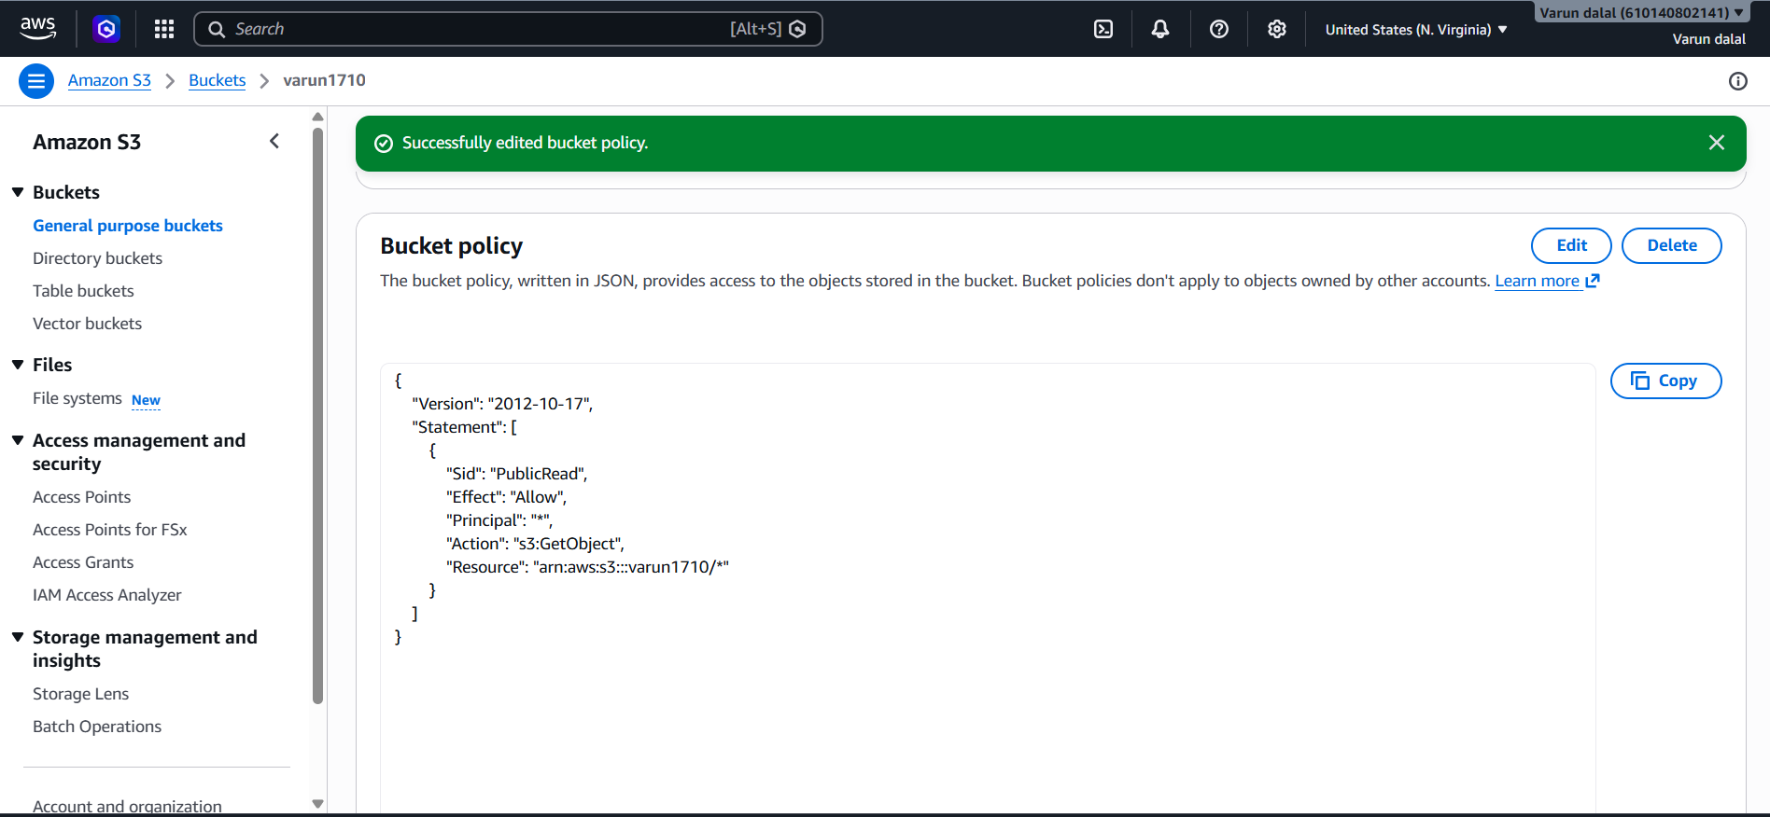
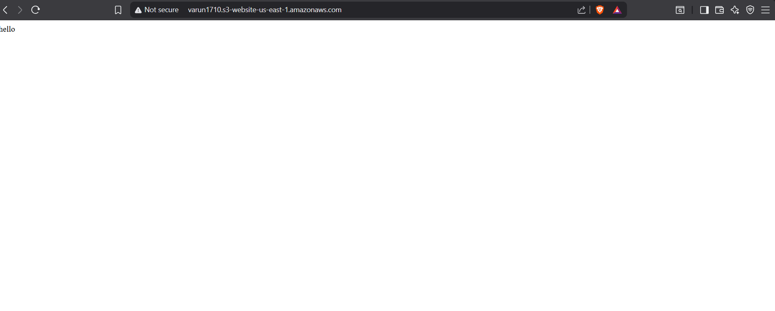

3.Enable cross-region replication on S3 buckets
Step 1: Create Source Bucket
- Open Amazon S3 Console.
- Click Create bucket.
- Enter bucket name:
varun1710
- Select Region:
US East (N. Virginia) - us-east-1
- Click Create bucket.
Validation
Navigate to S3 → Buckets.
Expected:
Bucket Name: varun1710
Region: us-east-1
Status: Available

Step 2: Create Destination Bucket
- Click Create bucket.
- Enter bucket name:
varun1710-replica
- Select a different Region:
US West (Oregon) - us-west-2
- Click Create bucket.
Validation
Bucket Name: varun1710-replica
Region: us-west-2
Status: Available

Step 3: Enable Versioning on Source Bucket
- Open varun1710.
- Select Properties.
- Scroll to Bucket Versioning.
- Click Edit.
- Choose Enable.
- Save changes.
Validation
Bucket Versioning: Enabled

Step 4: Enable Versioning on Destination Bucket
- Open varun1710-replica.
- Go to Properties.
- Under Bucket Versioning, click Edit.
- Enable versioning.
- Save changes.
Validation
Bucket Versioning: Enabled

Step 5: Create Replication Rule
- Open source bucket varun1710.
- Select Management tab.
- Under Replication Rules, click Create replication rule.
Configure Rule
Rule Name
CRR-Rule
Rule Status
Enabled
Choose Scope
Apply to all objects in the bucket
Click Next.
Validation
Rule Name: CRR-Rule
Status: Enabled

Step 6: Configure Destination Bucket
- Select:
Choose a bucket in another account or region
- Select destination bucket:
varun1710-replica
- Confirm destination region:
us-west-2
Validation
Destination Bucket: varun1710-replica
Destination Region: us-west-2

Step 7: Configure IAM Role
- Under IAM Role:
Create new role
- AWS automatically creates a replication role.
Example:
s3crr_role_for_varun1710
- Click Save.
Validation
Navigate to IAM → Roles.
Expected:
Role Name: s3crr_role_for_varun1710
Trusted Entity: s3.amazonaws.com

Step 8: Save Replication Rule
- Review all settings.
- Click Save.
Validation
Go to:
S3 → varun1710 → Management → Replication Rules
Expected:
Replication Rule: CRR-Rule
Status: Enabled

Step 9: Upload a New Object
- Open source bucket:
varun1710
- Upload a new file:
replication-test.txt
Validation
Object Uploaded Successfully

Step 10: Verify Replication
- Wait 1–2 minutes.
- Open destination bucket:
varun1710-replica
- Check the Objects tab.
Validation
Expected:
replication-test.txt
appears automatically in the destination bucket.

Final Validation
Source Bucket
Bucket Name: varun1710
Region: us-east-1
Versioning: Enabled
Destination Bucket
Bucket Name: varun1710-replica
Region: us-west-2
Versioning: Enabled
Replication Rule
Rule Name: CRR-Rule
Status: Enabled
IAM Role: s3crr_role_for_varun1710
Replication Test
Source Object : replication-test.txt
Destination Object : replication-test.txt
Replication Status : Successful
Result
✅ Cross-Region Replication (CRR) successfully configured between two S3 buckets in different AWS Regions, ensuring automatic replication of newly uploaded objects.

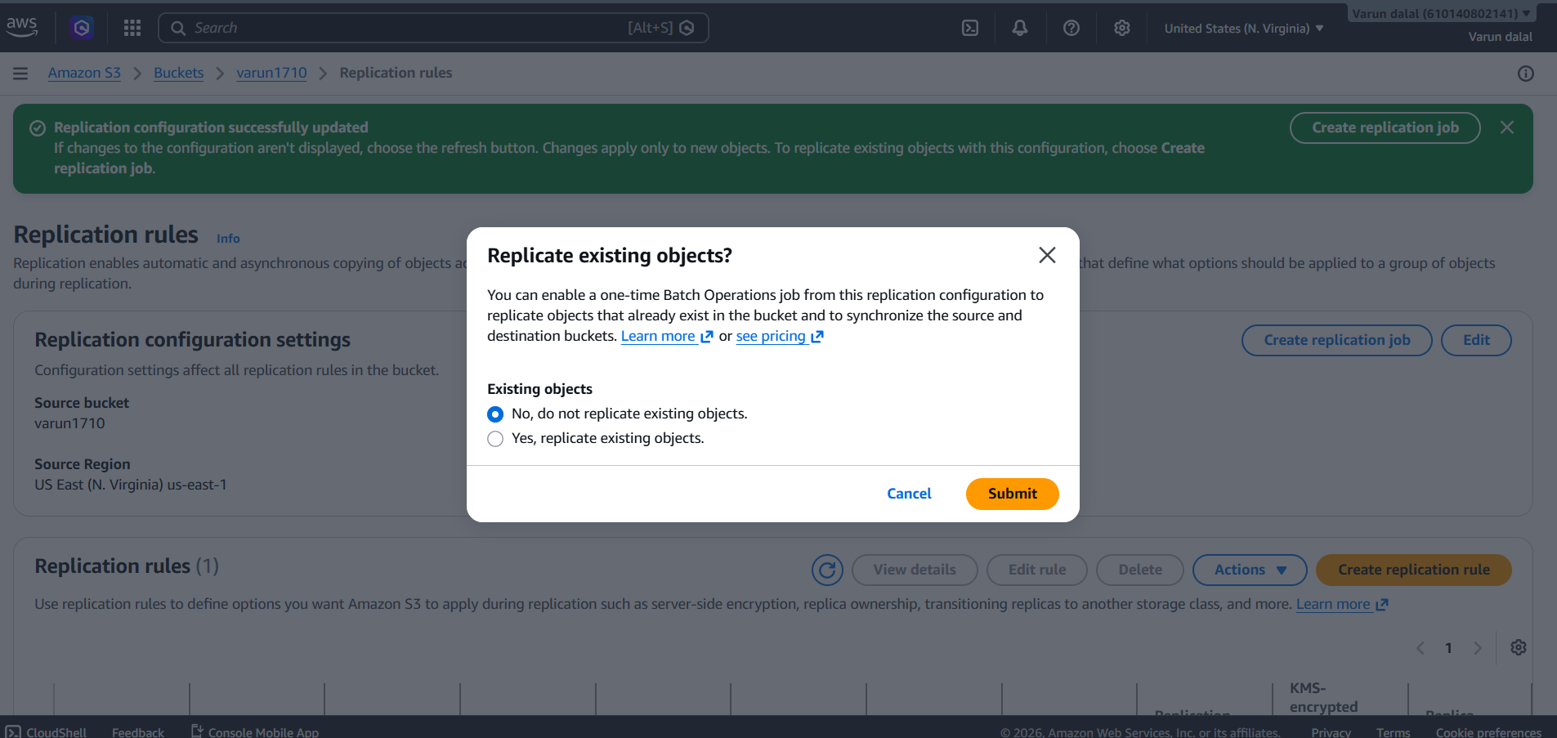
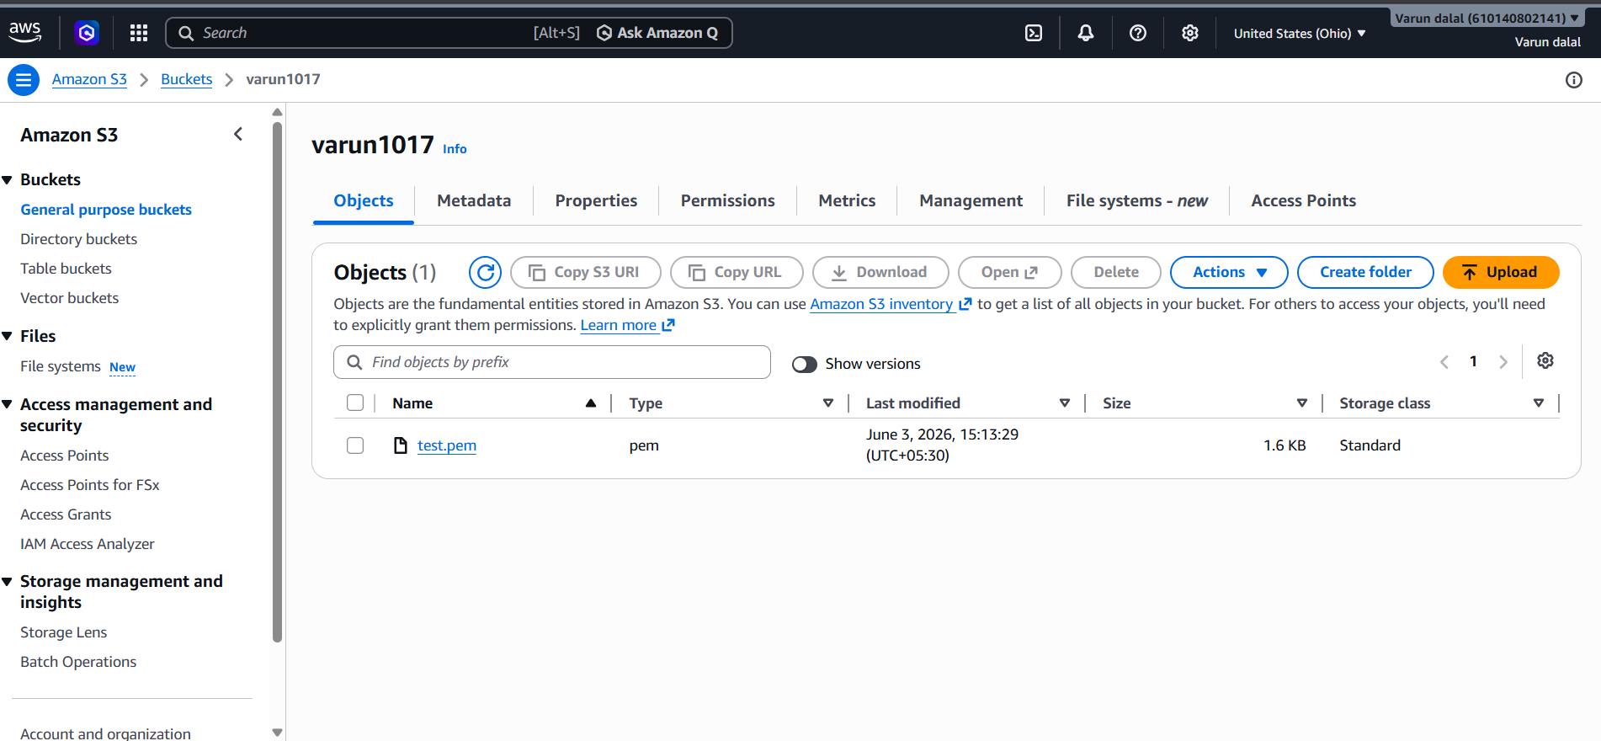
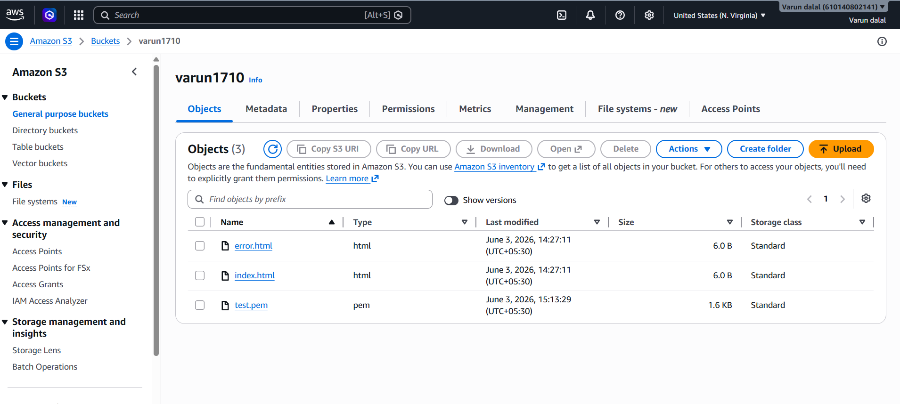

- Configure a bucket policy so only the Admin user can see the objects of the S3 bucket.
Step 1: Identify the Admin User ARN
- Open IAM Console.
- Click Users.
- Select the Admin user.
- Copy the User ARN.
Step 2: Open the S3 Bucket
- Go to Amazon S3.
- Select your bucket (for example, varun1710).
- Open the Permissions tab.
Step 3: Add Bucket Policy
- Under Bucket Policy, click Edit.
- Replace the account ID with your AWS account ID.
- Paste the following policy:
Step 4: Remove Permissions from Other Users (Optional)
If other IAM users have S3 permissions through IAM policies:
- Open IAM → Users.
- Select non-admin users.
- Detach policies such as:
  - AmazonS3FullAccess
  - AmazonS3ReadOnlyAccess
  - Custom S3 policies
Step 5: Test with Admin User
- Sign in as Admin.
- Open the S3 bucket.
- Open the Objects tab.
Step 6: Test with Another IAM User
- Sign in as a non-admin user.
- Try to open the bucket or view objects

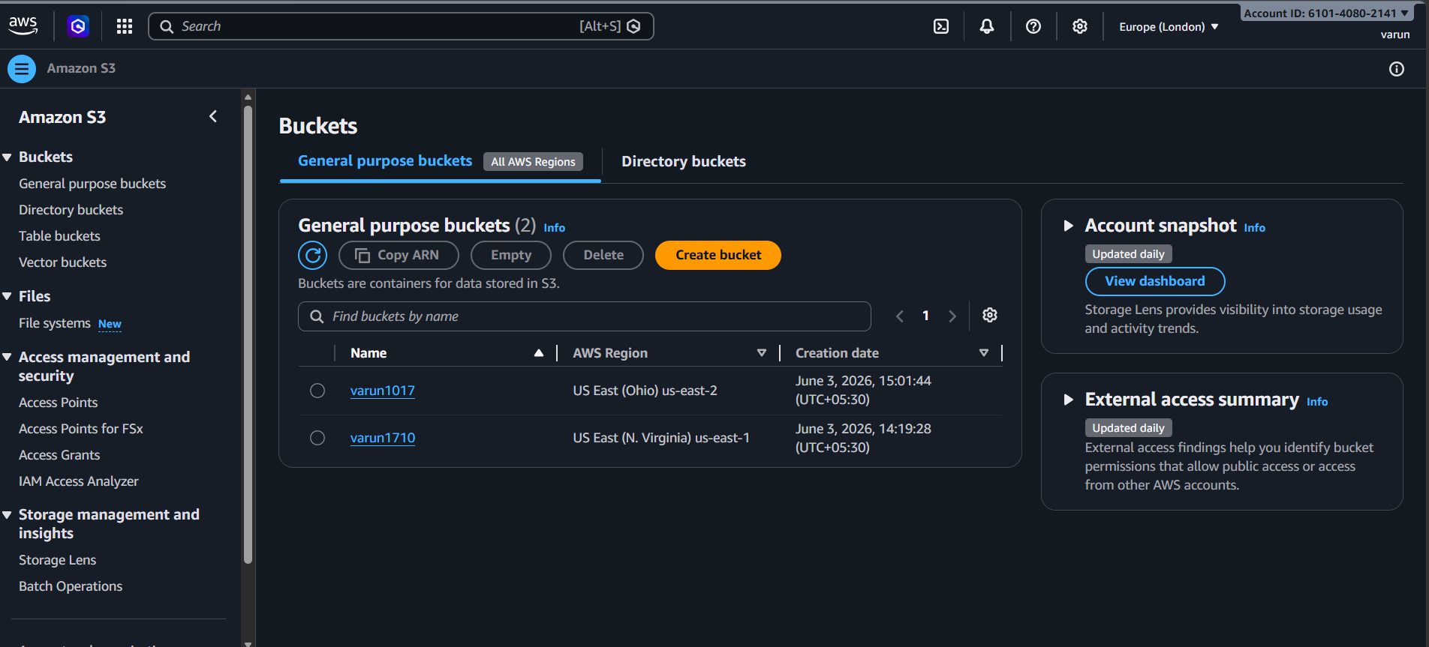

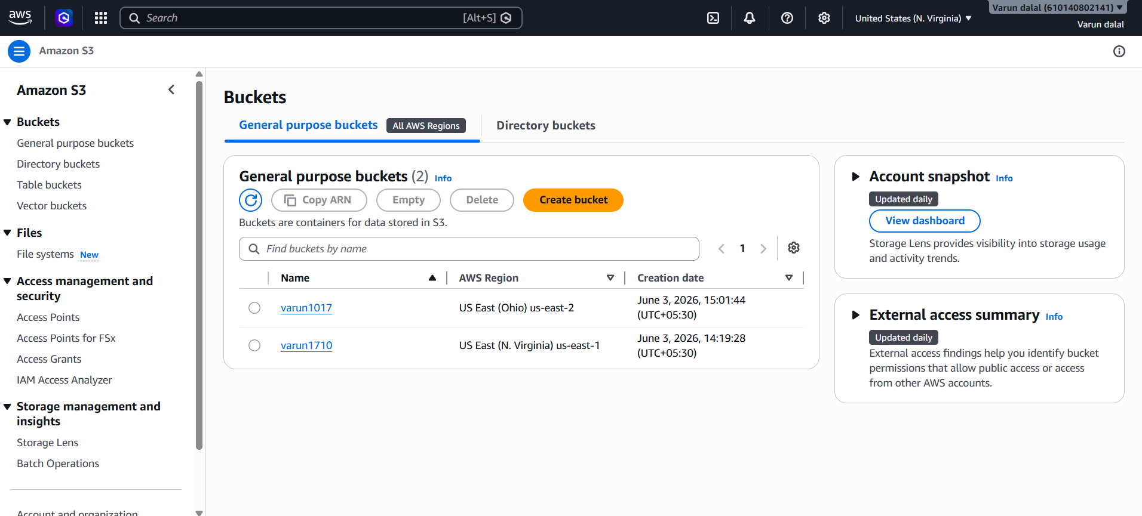
Final Validation
Test | Expected Result
Admin user lists bucket | ✅ Success
Admin user views objects | ✅ Success
Admin user downloads objects | ✅ Success
Other IAM user lists bucket | ❌ Access Denied
Other IAM user views objects | ❌ Access Denied
Result
✅ Configured an S3 bucket policy that allows only the Admin IAM user to list and view objects in the bucket while denying access to all other users.

5.Set up lifecycle policies to automatically transition or delete objects based on specific criteria.
Step 1: Open the S3 Bucket
- Sign in to the AWS Management Console.
- Navigate to Amazon S3.
- Select your bucket:
varun1710
- Click the Management tab.
Validation
Bucket: varun1710
Management Tab: Opened Successfully

Step 2: Create a Lifecycle Rule
- Under Lifecycle rules, click Create lifecycle rule.
- Enter a rule name:
lifecycle-rule-1
- Choose:
Apply to all objects in the bucket
- Acknowledge the warning and click Next.
Validation
Rule Name: lifecycle-rule-1
Scope: Entire Bucket

Step 3: Configure Transition Action
To move objects to a cheaper storage class:
- Under Lifecycle rule actions, select:
Transition current versions of objects between storage classes
- Configure:
Days after object creation: 30
Storage class: Standard-IA
Validation
Transition Action:
After 30 Days → Standard-IA

Step 4: Configure Expiration Action
To automatically delete objects:
- Select:
Expire current versions of objects
- Enter:
Days after object creation: 90
Validation
Expiration Action:
After 90 Days → Delete Object

Step 5: Review and Create Rule
- Review the lifecycle configuration.
- Click Create rule.
Validation
Navigate to:
S3 → varun1710 → Management → Lifecycle Rules
Expected:
Rule Name : lifecycle-rule-1
Status : Enabled

Step 6: Verify Lifecycle Rule
- Open Management tab.
- Check the Lifecycle Rules section.
Expected:
Lifecycle Rule:
✓ Enabled
Transition:
30 Days → Standard-IA
Expiration:
90 Days → Delete

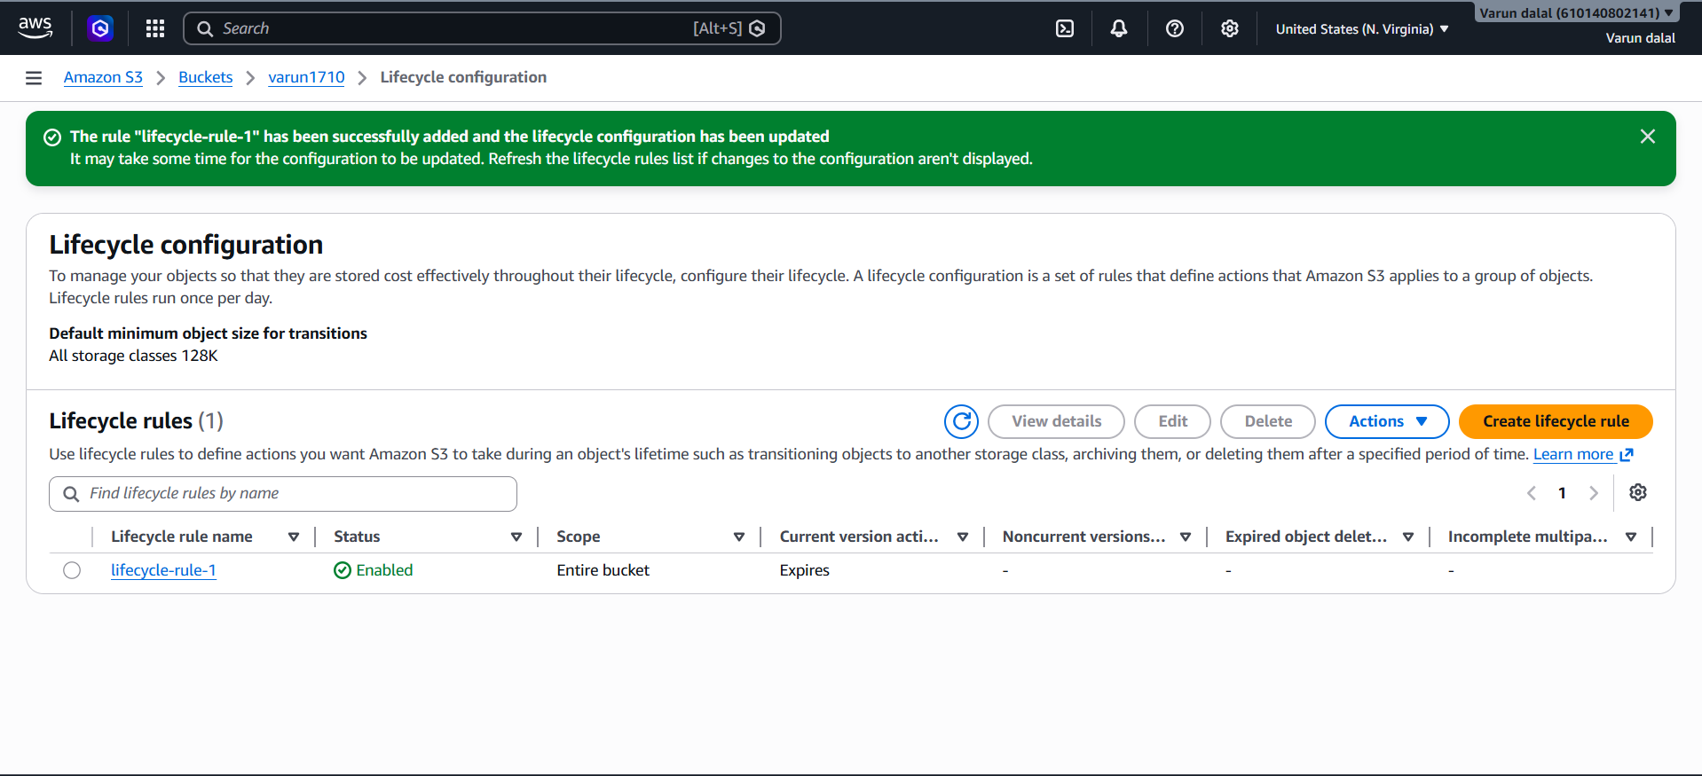
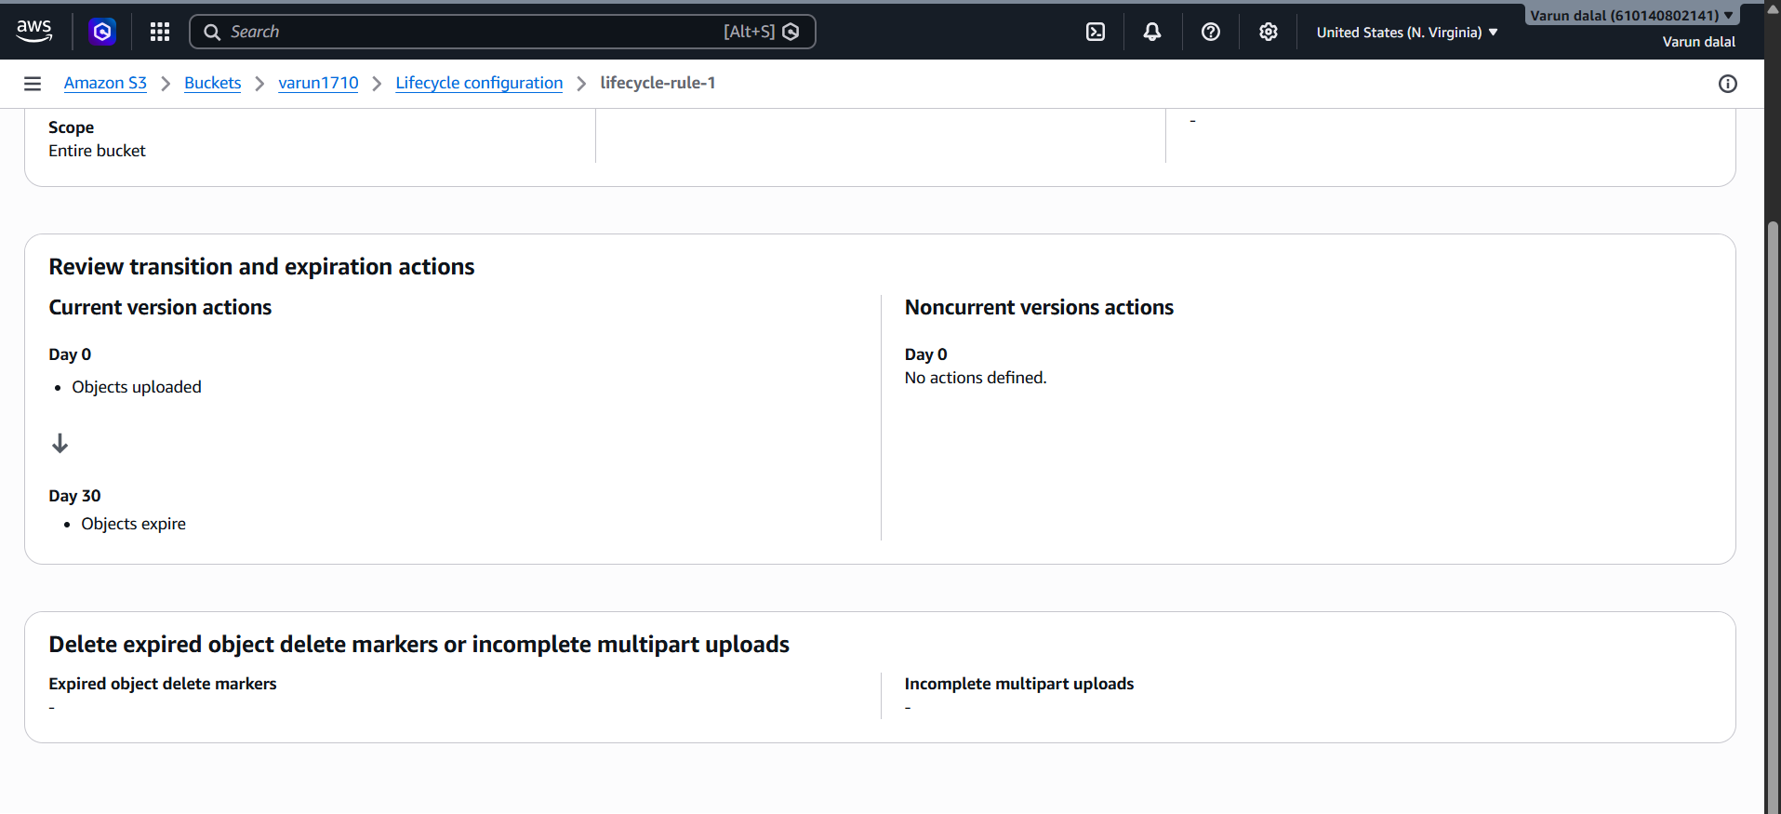

6.Push some objects to S3 using the AWS CLI
Objective-
The objective of this task is to upload files (objects) from a local machine or AWS CloudShell to an Amazon S3 bucket using the AWS CLI. This demonstrates how to manage and transfer data to S3 through command-line operations, enabling efficient and automated object storage management.

Step-
Step 1: Verify AWS CLI Configuration
Step 2: Create Sample Files
Step 3: Upload a Single Object
Upload file1.txt to bucket varun1710:
Step 4: Upload Multiple Objects
Step 5: Upload an Entire Folder
Step 6: Verify Objects in AWS Console
- Open Amazon S3.
- Select bucket varun1710.
- Open Objects tab.

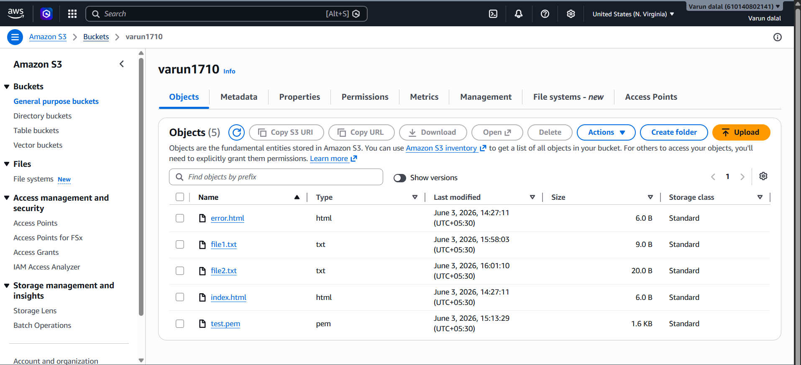

Validation-
The objects were successfully uploaded to the S3 bucket using the aws s3 cp command. The upload was verified by listing the bucket contents with the aws s3 ls command and confirming that the uploaded files were present in the bucket. The successful upload and visibility of the objects in both the AWS CLI output and S3 console validate that the task was completed successfully

7.Write a Bash script to create an S3 bucket.

Objective-
The objective of this task is to create an Amazon S3 bucket automatically using a Bash script and AWS CLI. This helps automate bucket creation, reduces manual effort, and demonstrates how AWS resources can be provisioned through scripting for efficient cloud management. ✅

Steps to Run-
- Create the script file:
nano create_s3_bucket.sh
- Paste the script and save it.
- Give execute permission:
- Run the script:
Bucket Name: varun1710-demo-1717425000

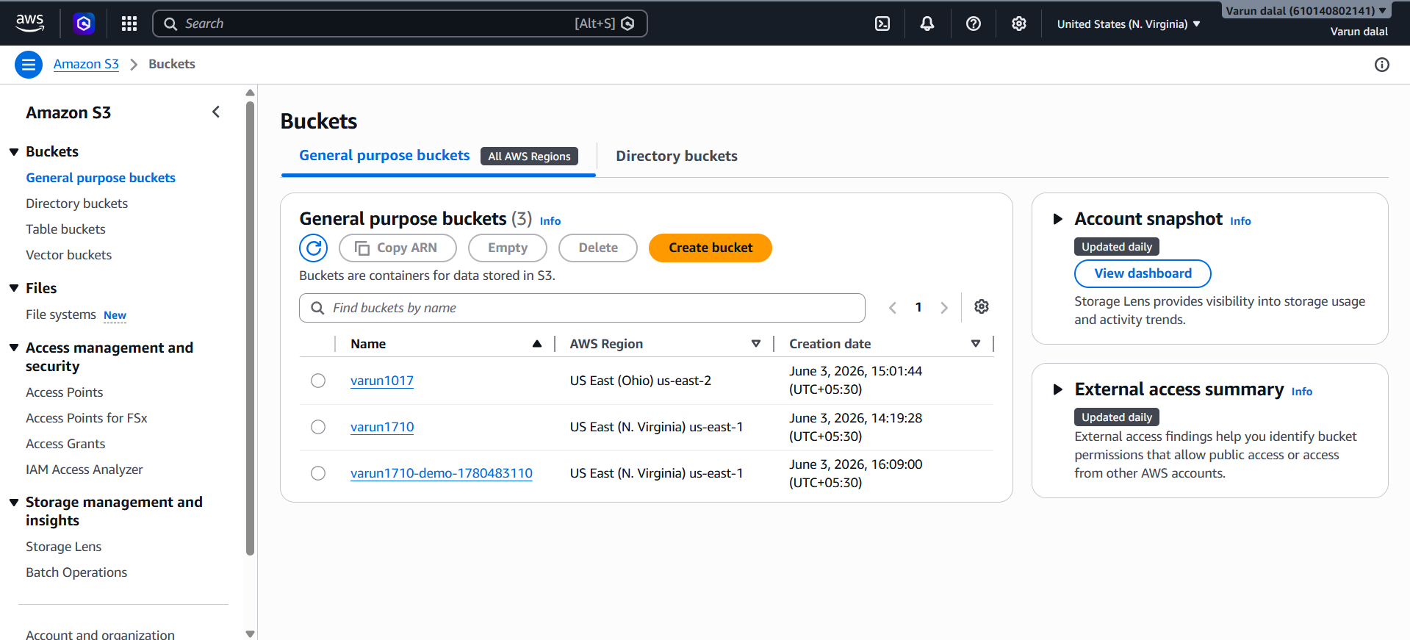
Validation-
The Bash script was executed successfully and created the S3 bucket in the specified AWS Region. The bucket creation was verified using the aws s3 ls and aws s3api head-bucket commands, which confirmed that the bucket exists and is accessible. The successful command execution and the presence of the bucket in the S3 console validate that the script performed the bucket creation operation correctly. ✅

8.Upload a 1 GB file to S3 using the CLI.
Objective-
The objective of this task is to upload a 1 GB file from a local machine or AWS CloudShell to an Amazon S3 bucket using the AWS CLI. This demonstrates how to transfer large files to S3, leverage AWS CLI for storage operations, and verify that the file is successfully stored in the bucket.

Steps-
Step 1: Create a 1 GB Test File
Step 2: Upload the File to S3
Step 3: Verify the Upload
Step 4: Verify Object Size
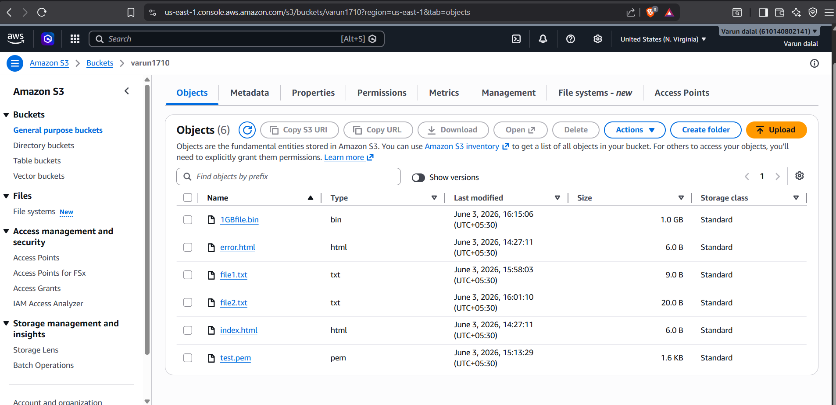

Result-
✅ Created a 1 GB file locally and uploaded it successfully to the S3 bucket using AWS CLI.
✅ Verified the object exists in S3 and has the expected size of 1,073,741,824 bytes (1 GiB).

Validation-
The 1 GB file was successfully uploaded to the S3 bucket using the AWS CLI aws s3 cp command. The upload was verified by listing the bucket contents with aws s3 ls s3://<bucket-name>/ and confirming that the file appeared in the bucket. Additionally, the object size matched the expected size of approximately 1 GB (1,073,741,824 bytes), confirming that the upload completed successfully without errors. ✅

